The SustainaSun Circular Photovoltaic Leasing Business Model: A System Dynamics Analysis

Introduction
This paper presents a System Dynamics analysis of a circular photovoltaic leasing business model designed to make solar energy more affordable, scalable, financially viable, operationally reliable, and environmentally credible over the full asset lifecycle. The model focuses on the strategic challenge of scaling a leased PV service without creating the very pressures that could undermine the business: rising lease prices, insufficient financing, maintenance backlogs, weak customer trust, poor reverse logistics, and unmanaged end-of-life waste. The model is therefore not just asking whether PV leasing is attractive in principle; it is asking under what conditions the business model remains viable as it scales.
The next section defines the core problem: how a leased PV business can grow without becoming financially fragile, operationally overloaded, or environmentally compromised. This section should identify the main stakeholders: customers, the provider, installers, financiers, regulators, grid operators, recyclers, communities, and the environment. It should also describe the five key failure modes: affordability failure, financing failure, service failure, circularity failure, and environmental credibility failure.

Then a CLD explains the system structure. This section should describe how reinforcing loops drive adoption, reputation, financing, economies of scale, and environmental credibility, while balancing loops constrain growth through market saturation, service pressure, financing limits, maintenance backlog, and lifecycle waste.

Then we describe what is inside and outside the model. Inside the boundary are customer adoption, lease affordability, service capacity, installation growth, financing, maintenance, circular recovery, environmental reputation, and policy support. Outside the boundary, at least initially, are detailed engineering design, grid power-flow modelling, household-level energy demand, tax accounting, and detailed PV degradation physics. This section should also state assumptions about customer behaviour, financing response, service capacity, and circular recovery.
The following section will translate the CLD into a stock-and-flow model with equations, units, parameters, and time delays. The canonical form explicitly expects stocks, flows, mathematical relationships, and unit consistency.
Then we conduct a structural validation: expert review, face validity, polarity checking, loop consistency, and comparison with known business-model behaviour. This section would add parameter estimation, historical fit, sensitivity testing, and extreme-condition tests. This is essential to building credibility before drawing policy conclusions.
With the full simulation model, the Results section presents the behaviour of key variables over time under current assumptions. We will start with the expected baseline behaviour qualitatively: early adoption increases visibility and credibility, but unmanaged growth can generate maintenance, financing, and waste pressures that eventually weaken adoption.
Then, the model will identify the interventions that it is designed to test: lease pricing, financing terms, government incentives, maintenance investment, repairability, component reuse, system lifetime, regulatory friction, customer trust, and environmental performance. This section will compare policy alternatives and identify high-leverage interventions.
We will end with a summary of what the model shows, practical recommendations, and candour about its limitations and future work.

Problem Statement
The problem addressed by this model is how a circular photovoltaic (PV) leasing business can scale adoption while remaining affordable for users, financially viable for the provider, operationally reliable, and environmentally beneficial over the full asset lifecycle.
The SustainaSun concept is built around providing PV systems through a leasing model rather than a conventional upfront purchase. This is strategically important because the upfront cost of PV systems can prevent households, building owners, or community users from adopting renewable energy even when the long-term environmental and energy-cost benefits are attractive. This highlights related barriers: affordability, customer trust, maintenance and repair, regulatory compliance, financing, reverse logistics, supplier relationships, ethical sourcing, and end-of-life material recovery. The business model is not only about installing solar panels; it is about creating a service system that can finance, deploy, maintain, recover, and reuse PV assets over time.
The core modelling challenge is that the business's success depends on several interacting feedback mechanisms. Lower monthly lease payments may increase customer adoption, but lower payments may also reduce revenue unless offset by financing support, economies of scale, component reuse, maintenance efficiency, or government incentives. Higher adoption can increase revenue and market visibility, but it also increases installation workload, maintenance obligations, future end-of-life material flows, and exposure to regulatory or grid-integration constraints. A simple linear business case would miss these dynamic trade-offs.
The model should therefore examine the conditions under which SustainaSun can avoid a common sustainability-business failure mode: a concept that is attractive in principle but becomes financially or operationally fragile as it scales. The business must maintain a balance between growth and capacity. If customer acquisition outpaces installation capacity, maintenance capacity, financing availability, or reverse logistics capability, the model could result in service backlogs, reduced customer satisfaction, lower system performance, higher costs, and reputational damage. These effects could then reduce adoption and undermine the original value proposition.
The environmental problem is equally important. PV leasing may support renewable energy adoption, but the environmental benefit is not automatic. If systems are poorly maintained, replaced too early, sourced through weak supply-chain practices, or disposed of without effective recovery, the lifecycle benefits may be lower than expected. This explicitly raises lifecycle assessment, repair, upgrade, reverse logistics, material recovery, and ethical supply chain considerations, suggesting that environmental performance should be treated as an endogenous outcome of the business model rather than a fixed assumption.
The social problem is affordability and access. A leasing model can make PV more accessible to users who cannot afford the capital cost of ownership. However, affordability depends on monthly lease prices, perceived value, energy savings, contract terms, reliability, customer support, and trust. If the lease price rises because of financing costs, maintenance costs, regulatory burdens, or weak component recovery, the model may fail to serve the users it is intended to support. The business model, therefore, needs to be tested not only for technical feasibility but also for equitable access and long-term customer value.
This is an appropriate System Dynamics problem because the system contains feedback loops, delays, accumulations, and nonlinear relationships. The central issue is not whether PV leasing can work in a static spreadsheet sense, but whether the business model remains coherent as adoption, installed capacity, service obligations, costs, financing needs, and environmental responsibilities accumulate over time.
The key stakeholders include customers, households, tenants, building owners, SustainaSun as the service provider, installers, maintenance providers, financiers, government agencies, regulators, energy providers, grid operators, suppliers, recyclers, communities, and the natural environment. Each stakeholder has a different performance criterion. Customers want affordable and reliable energy access. The provider needs positive cash flow and manageable operating costs. Financiers need acceptable risk and return. Regulators want compliance and grid reliability. Communities want lower emissions and fair access. The environment is affected by material extraction, energy generation, system lifetime, waste, recycling, and recovery outcomes.
The model should therefore address the following practical question:
How can SustainaSun scale a leased PV service model while maintaining affordability, financial viability, service quality, regulatory compliance, and lifecycle environmental benefit?
More specifically, the model should help assess whether the business can avoid five failure modes:
Failure mode | Description
Affordability failure | Lease prices rise above what target customers are willing or able to pay.
Financing failure | Upfront installation costs outpace available capital and lease revenue.
Service failure | Maintenance and repair demand outstrips service capacity, reducing performance and trust.
Circularity failure | Reverse logistics and component recovery lag behind system retirement and replacement.
Environmental credibility failure | Claimed sustainability benefits are undermined by poor lifecycle performance, waste, or supply chain impacts.
The desired outcome is a scalable business model in which customer adoption grows at a rate that is matched by financing capacity, installation capacity, maintenance capability, and circular recovery infrastructure. In that successful case, economies of scale, service learning, component reuse, government support, and customer trust reinforce one another. The business becomes more affordable, more reliable, and more environmentally credible as it grows.
The undesired outcome is a growth trap. In that case, early adoption creates pressure for faster expansion, but the organization lacks the capital, maintenance capacity, reverse logistics capability, or regulatory readiness to support the installed base. The result is rising costs, declining service quality, weaker customer satisfaction, growing end-of-life waste, and eventual stagnation or decline in adoption.
The purpose of the System Dynamics model is therefore to provide a structured way to test the long-term viability of the SustainaSun concept before making large implementation commitments. The model should support scenario analysis around lease pricing, financing terms, government incentives, maintenance investment, repairability, component reuse, system lifetime, regulatory friction, customer trust, and environmental performance. The model should not simply ask whether PV leasing is a good idea. It should ask under what conditions it remains a good idea as the system scales.

Causal Loop Diagram
This Causal Loop Diagram (CLD) represents the SustainaSun business model as a high-level causal structure with 37 variables, 51 causal links, 9 reinforcing loops, and 7 balancing loops. They are organized around adoption, affordability, service reliability, financing, environmental reputation, and circular-economy performance. The central growth engine is customer adoption, in which active customers strengthen word-of-mouth, trust, installed leased PV capacity, investor confidence, financing capacity, and environmental reputation. At the same time, the CLD highlights important constraints: growth can increase failures, maintenance backlog, cost pressure, and end-of-life waste, all of which can weaken service quality, affordability, and public credibility. The model therefore captures SustainaSun as a business ecosystem in which long-term success depends on managing reinforcing growth pressures while controlling and balancing pressures from market saturation, operational strain, financing risk, and lifecycle waste.
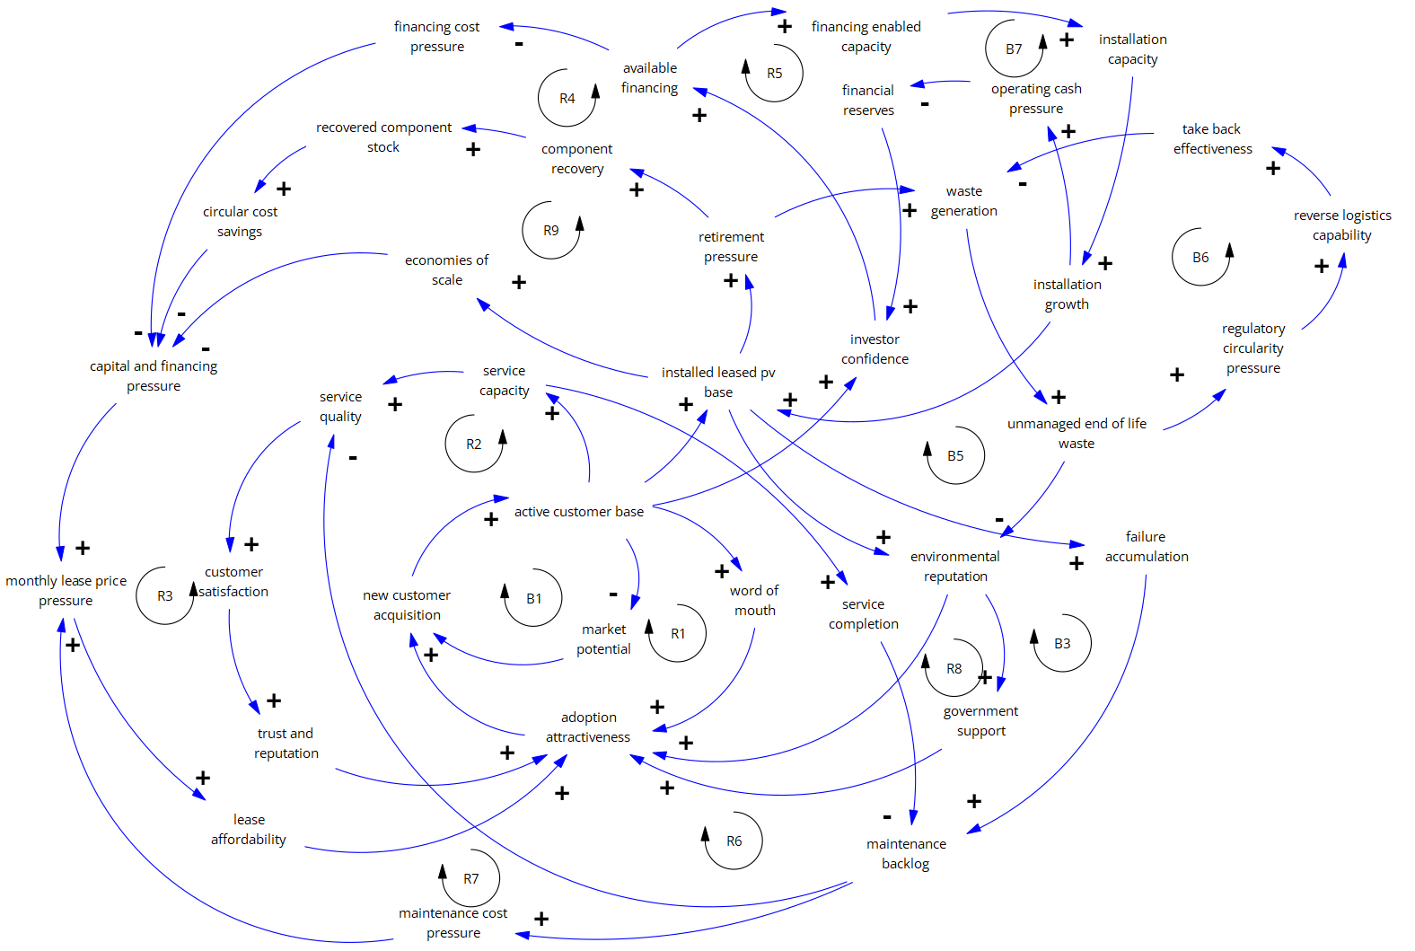

Loop number | Loop label | Causal chain
R1 | Market adoption through word of mouth | active customer base +→ word of mouth +→ adoption attractiveness +→ new customer acquisition +→ active customer base
R2 | Service learning, satisfaction, and trust | active customer base +→ service capacity +→ service quality +→ customer satisfaction +→ trust and reputation +→ adoption attractiveness +→ new customer acquisition +→ active customer base
R3 | Economies of scale improve affordability | active customer base +→ installed leased pv base +→ economies of scale −→ capital and financing pressure +→ monthly lease price pressure −→ lease affordability +→ adoption attractiveness +→ new customer acquisition +→ active customer base
R4 | Financial credibility reduces financing cost pressure | active customer base +→ investor confidence +→ available financing −→ financing cost pressure +→ capital and financing pressure +→ monthly lease price pressure −→ lease affordability +→ adoption attractiveness +→ new customer acquisition +→ active customer base
R5 | Financing expands installation capacity | active customer base +→ investor confidence +→ available financing +→ financing enabled capacity +→ installation capacity +→ installation growth +→ installed leased pv base +→ environmental reputation +→ adoption attractiveness +→ new customer acquisition +→ active customer base
B1 | Market saturation constrains acquisition | active customer base −→ market potential +→ new customer acquisition +→ active customer base
B2 | Maintenance cost pressure reduces affordability | active customer base +→ installed leased pv base +→ failure accumulation +→ maintenance backlog +→ maintenance cost pressure +→ monthly lease price pressure −→ lease affordability +→ adoption attractiveness +→ new customer acquisition +→ active customer base
B3 | Maintenance backlog erodes service quality | active customer base +→ installed leased pv base +→ failure accumulation +→ maintenance backlog −→ service quality +→ customer satisfaction +→ trust and reputation +→ adoption attractiveness +→ new customer acquisition +→ active customer base
R6 | Service completion protects reputation | active customer base +→ service capacity +→ service completion −→ maintenance backlog −→ service quality +→ customer satisfaction +→ trust and reputation +→ adoption attractiveness +→ new customer acquisition +→ active customer base
R7 | Environmental performance increases adoption | active customer base +→ installed leased pv base +→ environmental benefit generation +→ cumulative environmental benefit +→ environmental reputation +→ adoption attractiveness +→ new customer acquisition +→ active customer base
R8 | Environmental reputation strengthens policy support | active customer base +→ installed leased pv base +→ environmental benefit generation +→ cumulative environmental benefit +→ environmental reputation +→ government support +→ adoption attractiveness +→ new customer acquisition +→ active customer base
R9 | Circular component reuse lowers lifecycle cost | active customer base +→ installed leased pv base +→ retirement pressure +→ component recovery +→ recovered component stock +→ circular cost savings −→ capital and financing pressure +→ monthly lease price pressure −→ lease affordability +→ adoption attractiveness +→ new customer acquisition +→ active customer base
B4 | End-of-life waste damages environmental credibility | active customer base +→ installed leased pv base +→ retirement pressure +→ waste generation +→ unmanaged end of life waste −→ environmental reputation +→ adoption attractiveness +→ new customer acquisition +→ active customer base
B5 | Take-back effectiveness reduces unmanaged waste | unmanaged end of life waste +→ regulatory circularity pressure +→ take back effectiveness −→ waste generation +→ unmanaged end of life waste
B6 | Reverse logistics response reduces unmanaged waste | unmanaged end of life waste +→ regulatory circularity pressure +→ reverse logistics capability +→ take back effectiveness −→ waste generation +→ unmanaged end of life waste
B7 | Installation cash pressure constrains growth capacity | installation growth +→ operating cash pressure −→ financial reserves +→ investor confidence +→ +→ available financing +→ financing enabled capacity +→ installation capacity +→ installation growth

